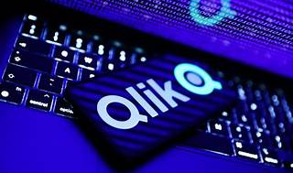

Explore

**Qlik** is a software company that provides a business analytics platform. Their main products include **Qlik Replicate** for data integration and **Qlik Sense** for business intelligence. [Additionally, they offer **QlikView**, a tool for visually analyzing data relationships1](https://en.wikipedia.org/wiki/Qlik).

Here are **five free learning resources** to help you get started with Qlik:

1. [**Qlik Learning Portal**](https://learning.qlik.com/): Access self-paced courses covering various topics, from visualizations to installation.
2. [**Qlik Continuous Classroom**](https://www.qlik.com/us/services/training/self-paced-learning): Explore self-paced courses on Qlik’s platform services, including data integration and analytics.
3. [**Qlik Community**](https://community.qlik.com/t5/Official-Support-Articles/How-to-Access-Qlik-Training-resources-and-Register-for/ta-p/2143329): Find free online courses, self-paced learning, and instructor-led training.
4. [**Qlik Free Data Analytics Training**](https://www.qlik.com/us/services/training/free-training): Learn from basic to advanced topics, improve data literacy, and analyze data confidently.
5. [**Qlik Help**](https://help.qlik.com/): Explore video tutorials and resources for Qlik Replicate and other Qlik products[2](https://community.qlik.com/t5/Official-Support-Articles/How-to-Access-Qlik-Training-resources-and-Register-for/ta-p/2143329)[3](https://www.qlik.com/us/services/training/self-paced-learning)[4](https://www.qlik.com/us/services/training/free-training).